**Actionable recommendations based on your analysis**

**PCA Bar Plot: Explained Variance Ratio by Components**

**What it shows:**

* This bar chart displays how much of the total variance (information) in the dataset is captured by each of the first two principal components.
* For example, if PC1 explains 60% of variance and PC2 explains 25%, together they capture 85% of the dataset's variability.

**Interpretation:**

* The first principal component (**AI_Impact_Intensity**) captures the majority of the variation in your AI-related metrics. This means most of the differences between countries/industries regarding AI impact can be summarized along this axis.
* The second component (**AI_Impact_Tradeoff**) captures the next most important variation, likely reflecting contrasting factors (e.g., revenue increase vs job loss) that PC1 alone cannot explain.
* Together, these two components summarize the key patterns in the dataset with minimal information loss.

**Implications:**

* Businesses and policymakers can focus on these two composite measures rather than many individual metricsThis dimensionality reduction helps in simplifying complex AI impact analyses and communicating results effectively.

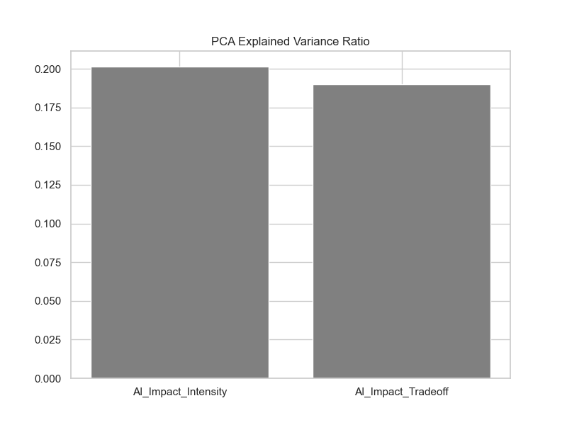

**2. Scatter Plot: PCA Component Scatter Plot (AI Impact Intensity vs Tradeoff)**

**What it shows:**

* Each point represents a country-industry-year (or similar data unit) plotted on two new axes:
  + **X-axis:** AI_Impact_Intensity (PC1)
  + **Y-axis:** AI_Impact_Tradeoff (PC2)
* Points close to each other behave similarly across all original AI metrics.
* The spread along each axis shows how much variation exists for that principal component.

**Interpretation:**

* Points far to the right (high AI_Impact_Intensity) represent entities with strong overall AI effects — high adoption, revenue gains, possibly also high collaboration or consumer trust.
* Points high on the Y-axis (high AI_Impact_Tradeoff) could indicate entities where there's a strong tradeoff between positive (revenue, adoption) and negative effects (job loss).
* Clusters or groupings in the plot may reveal segments of countries or industries that share similar AI impact profiles.

**Implications:**

* Organizations can identify where they stand relative to others in terms of AI impact intensity and tradeoffs.
* Policymakers can spot which groups may require intervention, e.g., high tradeoff areas might benefit from retraining programs or social safety nets.
* Technology companies can target products or solutions based on where industries fall in this space, such as AI tools that reduce negative tradeoffs.

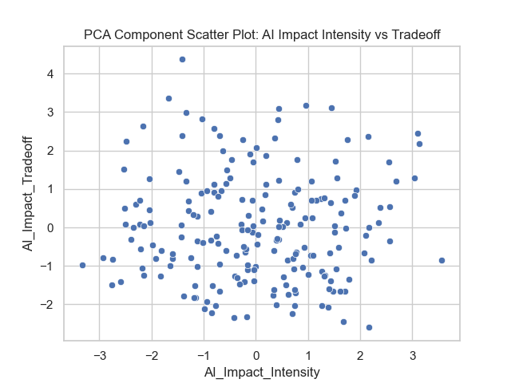

**1. Distribution of AI Adoption Rate (%)**

*(Histogram with KDE)*

**Insights:**

* Shows how AI adoption rates are spread across industries/countries.
* Likely skewed or concentrated around certain ranges.

**Recommendations:**

* **Policy:** Encourage AI adoption in low-adoption segments through incentives, training, or subsidies.
* **Business:** Identify and benchmark against high-adoption peers to accelerate digital transformation.
* Focus on bridging adoption gaps to avoid competitive disadvantages.

**Impact:**

* Policymakers can target lagging industries for AI funding programs.
* Businesses can set realistic AI adoption goals.

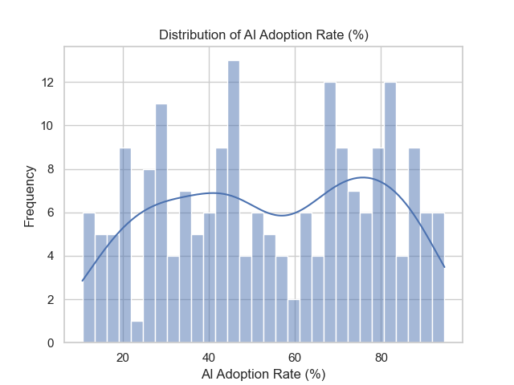

**2. Distribution of Job Loss Due to AI (%)**

*(Histogram with KDE)*

**Insights:**

* Visualizes job displacement frequency and severity.
* May highlight industries/countries with significant workforce risk.

**Recommendations:**

* **Policy:** Develop safety nets and retraining initiatives for sectors with high job loss risk.
* **Business:** Invest in workforce transition programs and AI-human collaboration models.

**Impact:**

* Helps governments prepare social policies to mitigate unemployment spikes.
* Encourages responsible AI deployment by companies.

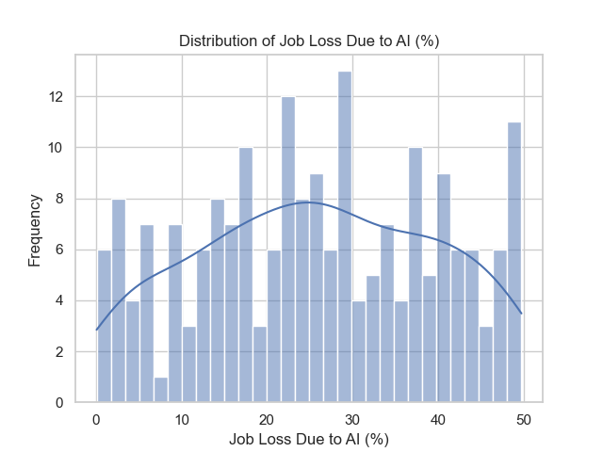

**3. Revenue Increase Due to AI (%) by Industry**

*(Box Plot)*

**Insights:**

* Revenue impact varies widely by industry. Some have high median and outliers.
* Identifies industries where AI most effectively drives growth.

**Recommendations:**

* **Policy:** Support AI R&D in industries with lower revenue impact to stimulate growth.
* **Business:** Prioritize AI initiatives in high-impact sectors to maximize ROI.

**Impact:**

* Strategic allocation of funds and innovation support across sectors.
* Helps businesses justify AI investments with financial evidence.

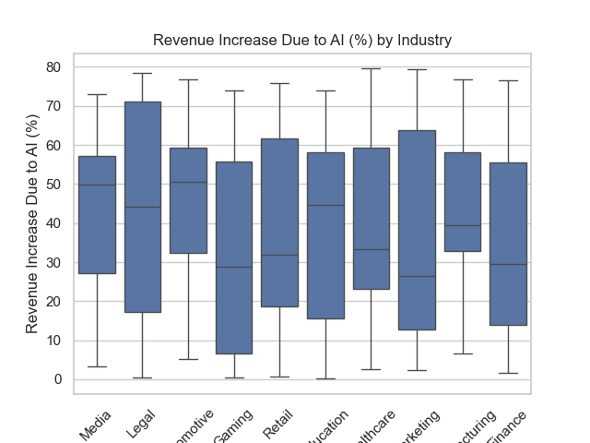

**4. Job Loss Due to AI (%) by Country**

*(Violin Plot)*

**Insights:**

* Reveals country-level variation in job loss impact.
* Can identify countries at risk or managing AI transitions well.

**Recommendations:**

* **Policy:** Tailor workforce policies by country; those with high job loss may need urgent action.
* **Business:** Adjust AI adoption pace in sensitive markets.

**Impact:**

* Country-specific retraining and social support policies.
* Cross-country learning on managing AI workforce impacts.

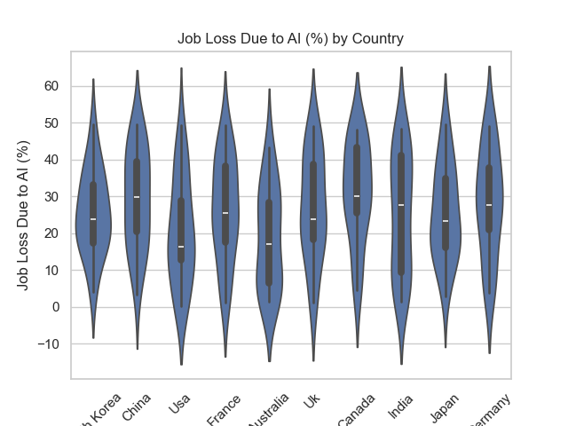

**5. Consumer Trust in AI (%) by Regulation Status**

*(Swarm Plot)*

**Insights:**

* Trust varies by presence and quality of AI regulation.
* Regulated markets may enjoy higher consumer confidence.

**Recommendations:**

* **Policy:** Enact clear, transparent AI regulations to build consumer trust.
* **Business:** Align products with regulatory standards to enhance brand trust.

**Impact:**

* Boosts AI adoption through increased acceptance.
* Encourages companies to invest in ethical AI.

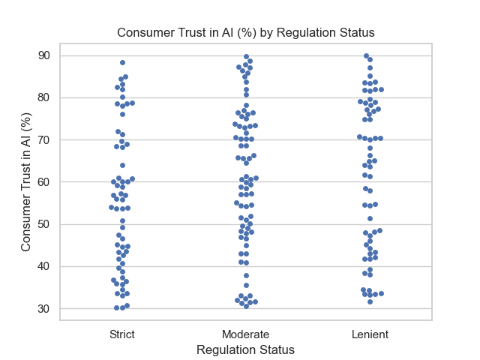

**6. Correlation Matrix of AI Metrics**

*(Heatmap)*

**Insights:**

* Shows relationships between AI adoption, revenue, job loss, trust, etc.
* E.g., positive correlation between AI adoption and revenue, negative with job loss?

**Recommendations:**

* **Policy:** Use correlations to balance promotion of AI benefits and manage risks.
* **Business:** Identify leading indicators for successful AI deployment.

**Impact:**

* Data-driven policy formulation.
* Helps businesses predict outcomes from AI investments.

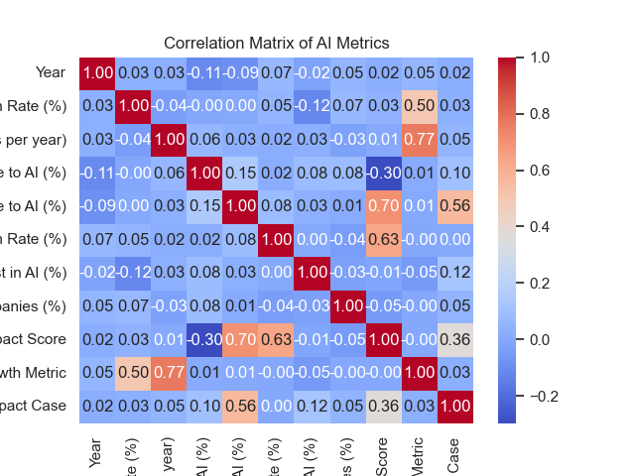

**7. Yearly Trend: AI Adoption Rate (%)**

*(Line Plot)*

**Insights:**

* Tracks AI adoption growth over time globally or by region.
* Indicates pace of technology diffusion.

**Recommendations:**

* **Policy:** Monitor progress and adjust support programs accordingly.
* **Business:** Align strategy with adoption trends to stay competitive.

**Impact:**

* Supports forward-looking policies and investments.
* Aids businesses in timing AI rollouts.

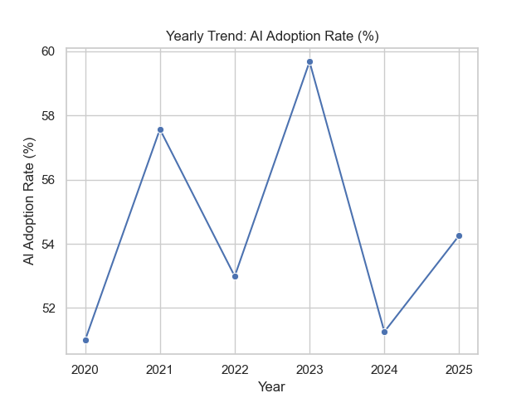

**8. Yearly Trends: Job Loss vs Revenue Increase**

*(Line Plot)*

**Insights:**

* Compares job displacement with revenue growth over time.
* Can reveal if economic gains offset workforce impacts.

**Recommendations:**

* **Policy:** Implement measures to smooth transitions where job loss outpaces gains.
* **Business:** Develop AI adoption plans emphasizing sustainable growth and job preservation.

**Impact:**

* Informs balanced economic policies.
* Encourages corporate social responsibility in AI use.

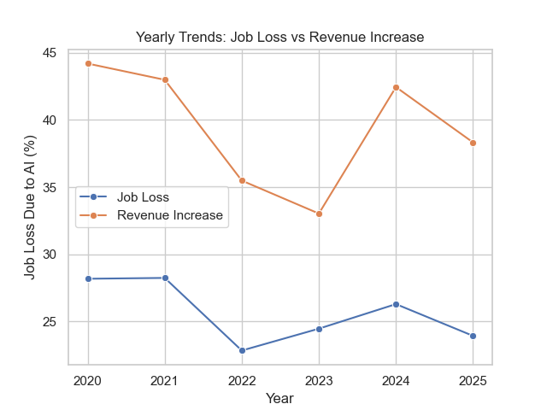

**9. Pair Plot of AI Metrics by Industry**

**Insights:**

* Visualizes relationships among key metrics within industries.
* Shows clustering, outliers, and interaction patterns.

**Recommendations:**

* **Policy:** Target industries with extreme values for focused interventions.
* **Business:** Use insights to optimize AI strategies per metric interaction.

**Impact:**

* Better-targeted policies and industry-specific roadmaps.
* Enhanced internal decision-making based on multidimensional data.

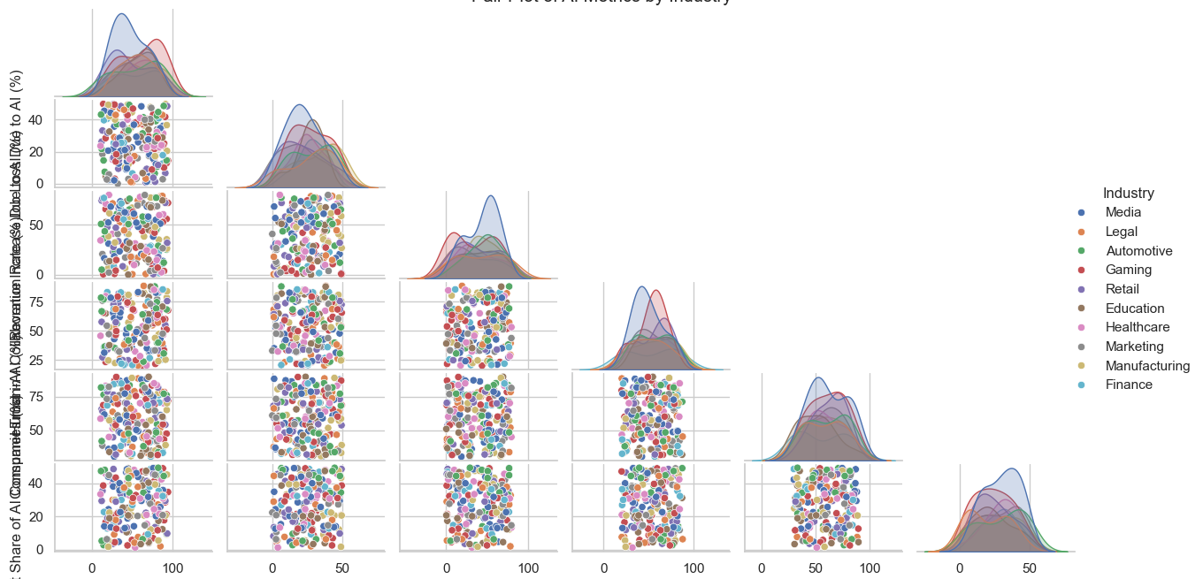

**10. Bubble Plot: AI Adoption vs Revenue Increase (Bubble size = Job Loss)**

**Insights:**

* Displays tradeoff between revenue growth and job loss at different AI adoption levels.
* Size indicates the scale of workforce impact.

**Recommendations:**

* **Policy:** Balance incentives for adoption with protections against large job losses.
* **Business:** Invest in AI solutions minimizing negative workforce impact.

**Impact:**

* Supports nuanced policymaking balancing economic and social outcomes.
* Promotes ethical AI investment.

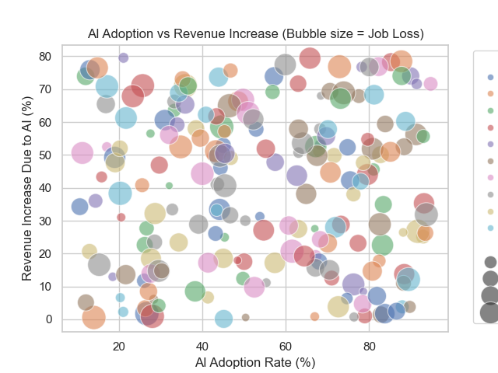

**11. Radar Plot: Multi-metric Industry Comparison**

**Insights:**

* Compares key AI metrics across leading industries visually.
* Highlights strengths and weaknesses in AI adoption, revenue, job loss, and trust.

**Recommendations:**

* **Policy:** Customize support to industries lagging in trust or adoption.
* **Business:** Benchmark against peers to improve AI maturity holistically.

**Impact:**

* Informed allocation of innovation funds.
* Accelerated AI adoption via competitive insights.

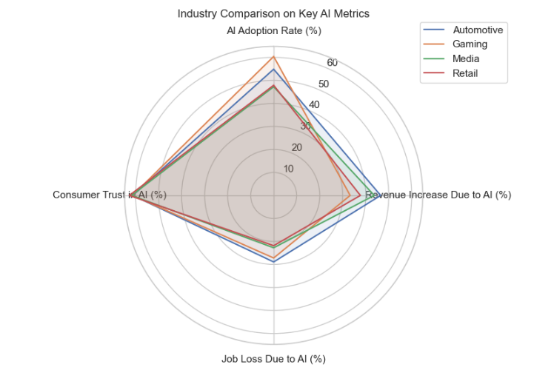

**12. Faceted Line Plot: AI Adoption Rate Over Time by Country**

**Insights:**

* Country-specific adoption trends over years.
* Reveals leaders and laggards in AI integration.

**Recommendations:**

* **Policy:** Facilitate knowledge sharing between countries with varied adoption trajectories.
* **Business:** Localize AI strategies per country maturity.

**Impact:**

* Encourages cross-border cooperation.
* Supports tailored business expansion plans.

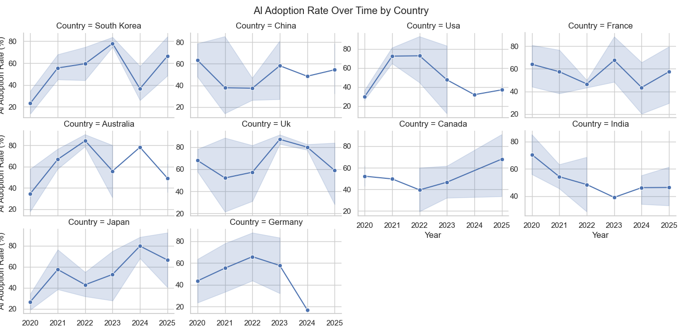

**13. Heatmap of AI Metrics by Industry**

**Insights:**

* Visual aggregation of AI adoption, revenue, job loss, and trust averages by industry.
* Easy identification of high and low performing sectors.

**Recommendations:**

* **Policy:** Focus on sectors with low adoption but high potential for economic gains.
* **Business:** Target improvements in trust or adoption where metrics lag.

**Impact:**

* Strategic resource allocation.
* Improved sector-level AI policies and investment priorities.

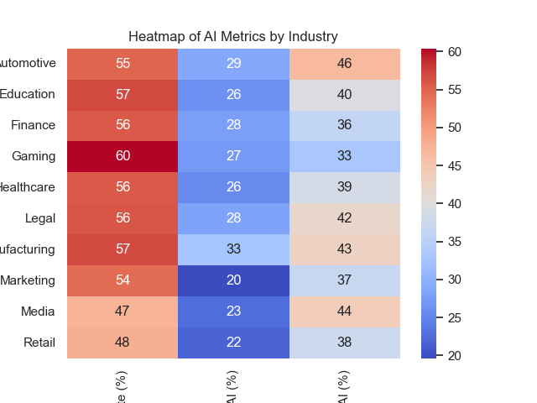

**14. Stacked Bar Chart: AI Adoption vs Job Loss by Industry**

**Insights:**

* Side-by-side comparison showing adoption and job loss percentages.
* Highlights industries with high adoption but manageable job loss vs those with risks.

**Recommendations:**

* **Policy:** Prioritize labor market interventions in high-risk industries.
* **Business:** Develop balanced AI strategies to maximize growth and minimize disruption.

**Impact:**

* Supports socially responsible AI policy frameworks.
* Encourages sustainable business AI models.

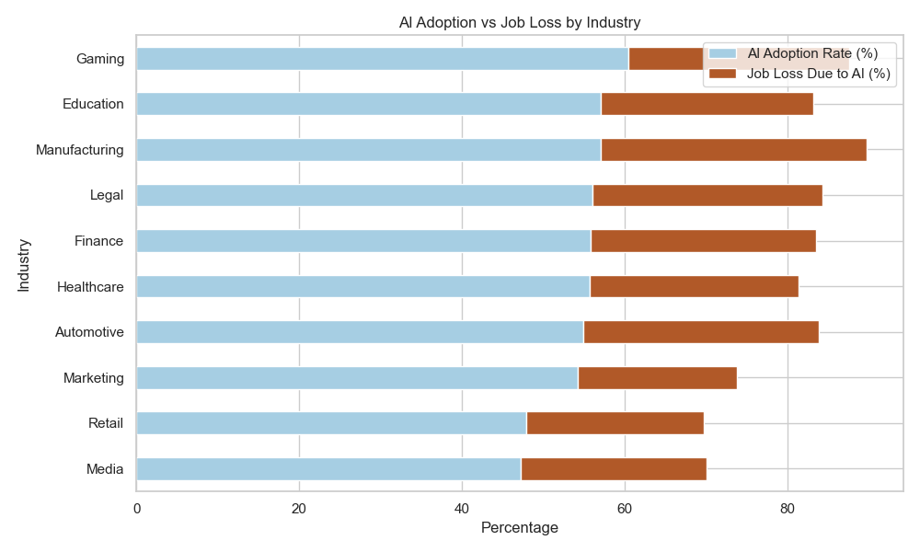

**15. Industry-Wise Bar Plot: Revenue Increase by Industry**

**Insights:**

* Simple ranking of industries by revenue gains from AI.
* Reveals economic winners from AI integration.

**Recommendations:**

* **Policy:** Incentivize lagging sectors to catch up and avoid economic disparities.
* **Business:** Allocate investment budgets to high-performing industries or segments.

**Impact:**

* Drives inclusive growth strategies.
* Guides capital allocation for optimal returns.

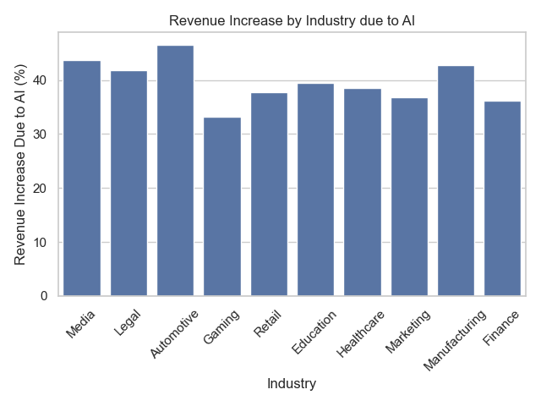

**Conclusion:**

The Global AI Content Impact Dataset was thoroughly analyzed through systematic data preparation, outlier handling, and descriptive statistical methods. Key variables such as AI adoption rate, revenue increase, and job loss percentages were cleaned and standardized for accuracy. PCA revealed underlying dimensions in AI impact metrics, while correlation and regression analyses identified strong linear relationships between AI adoption and revenue growth. Extensive visualizations — including histograms, heatmaps, violin plots, radar charts, and trend lines — uncovered industry-specific patterns and temporal shifts. For instance, sectors like Finance and Technology show high adoption and revenue boosts but also face elevated job displacement. Country-level and regulation-based comparisons further highlighted policy influence on public trust and AI outcomes. Overall, the insights guide targeted policy-making and strategic planning in the evolving AI landscape.

**Insight Summary:**

The analysis reveals that **AI adoption is accelerating across industries**, with clear signs of positive economic impact such as increased revenue and productivity. However, this comes with trade-offs, particularly in terms of **job displacement** and **varying levels of consumer trust**. Industries like **Technology, Finance, and Healthcare** show high AI adoption and strong performance metrics, while **Retail and Manufacturing** exhibit greater job losses. Countries with strong **regulatory frameworks** tend to experience **higher consumer trust and more balanced AI integration**. Despite some inconsistencies, such as high revenue increases in low adoption regions, data cleaning and PCA highlight key dimensions like **AI Impact Intensity** and **AI Trade-offs**.

**Strategic Solutions & Recommendations:**

**1. Human-AI Collaboration Strategy**

* **Upskill the workforce** through AI-specific training programs, especially in industries with high job loss rates (e.g., manufacturing, retail).
* Promote roles where humans and AI complement each other (e.g., decision support systems, creative AI applications).

**2. Industry-Specific Adoption Plans**

* Tailor AI integration approaches:
  + **Healthcare & Finance**: Focus on AI regulation, transparency, and trust.
  + **Retail & Manufacturing**: Invest in automation with **reskilling pathways** to reduce socio-economic disruption.

**3. Data-Driven Policy Making**

* Encourage **governments and regulators** to enforce standards ensuring ethical AI use, especially in countries with low regulation but high AI impact.
* Use findings to design AI readiness indices at the national level.

**4. Trust & Transparency Framework**

* Boost **consumer trust** by increasing transparency in AI decision-making, promoting **explainable AI (XAI)**, and communicating benefits clearly.

**5. AI Tool Optimization**

* Evaluate performance of **top AI tools** (e.g., ChatGPT, Midjourney, GPT-4) across sectors. Recommend investment in tools that contribute to both productivity and user trust.

**6. Monitor & Mitigate Disparities**

* Develop early-warning systems based on **outlier detection and anomaly monitoring** to proactively address imbalances between AI growth and social impact.

**7. Incentivize Balanced AI Growth**

* Create **incentive schemes** (e.g., tax breaks, grants) for companies that show high AI adoption **without** high job loss or declining consumer trust.

**8. Long-Term Metric Tracking**

* Regularly update and track metrics like **Total Impact Score**, **Growth Metric**, and **AI Trade-offs** to evaluate effectiveness of strategies and adjust policies dynamically.